Persistence of EMF models in a Column Oriented Databases with Versioning

- 27-11-2008 R. de Laat Initial Revision
- 28-11-2008 R. de Laat Review L. van Berlo, added Strings/Blobs references
- 17-12-2008 R. de Laat Added changeset interface description

Assumptions and Definitions

- Column oriented databases essentially store key/value pairs, both represented as byte[] (byte arrays) of arbitrary length.
- A column oriented database has the notion of tables/tablespaces.
- The column database will automatically index the keys, so retrieval will be fast
- Relations between EMF entities should be stored and re-constructed on read
- Versioning will be done on Object-level. As soon as one of the objects attributes or references changes, there will be a new Revision of this object.
- Version management will be done based on merging and not locking, the database does not provide any merging facilities, those are the clients responsibilities.

Storage

Dual engine
The storage engine can be accessed in two different ways. One versioned and one unversioned way. The notion of using both (instead of only versioned, which is the requirement) came from the fact that there is a bunch of meta-data to be stored that facilitates the versioning capabilities (like user, project, revision etc...), those objects can be represented in an EMF model too. It would be extensive to build a different persistence system for this. It is of course impossible to use the versioned system to store these meta-objects because that results in a chicken-egg problem.

This document describes mainly the versioned system, because the unversioned one will simply be the versioned one without all the version-specific information.

Every EMF object will be stored in one row (record). Every new object (to the system) will get a unique Object Identifier (OID), this OID will never change, also every revision of this object will still use the same OID. The OID is part of the key, other parts of the key are the Project ID (PID) and Revision ID (RID), which will be described later.

To make reading the value of a row easy and fast, values will have a fixed length, based on the class that is being stored. Every class will have it's own table, therefore all keys and values in a certain table are the same length.

Class Lookup Table
The Class Lookup Table (CLT) maps Class Identifiers (CID) to the actual class names (String). At certain points, references will be made to the CID's instead of the actual class names to achieve performance and space efficiency.

Note: This system could eventually also be used to support evolution of structure.

Object storage
An EMF object consists of references and attributes. Attributes are simple objects that have no references to other objects (or attributes for that matter), they are of primitive types. References point to complex types, e.a. objects that can itself have references or attributes.

Keys
Keys consist of a PID + OID + Revision ID (RID). A Revision ID is of type Integer. The decision on these fields and their order is based on the fact that all keys in the database are ordered. So it's easy to get all OID's within one PID (using cursors). The same counts for all RID's within an OID. It might come in handy to store revision-id's as their subtract of Integer.MAX_INT, in that case when getting the cursor of a certain PID + OID, you will automatically have the latest revision (the one usually requested the most) as its first result.

Values
To determine how to store an object, the persisting code will look at the EMF class (by EMF reflection) and walk through all the StructuralFeatures (which are basically attributes and references). An attribute has a fixed length based on its primitive type (see primitive types) and a reference consists of a OID + RID.

Primitive types

Java Type | Number of bytes
Byte | 1
Short | 2
Integer | 4
Long | 8
Float | 4
Double | 8
Boolean | 1
Char | 2
String | 4, see “Variable length types”
Date | 8

Primitive types cannot be null. Java defaults will be used to represent undefined values.

References
A reference to another object is constructed as a CID + OID. Note the PID and RID are not part of the reference, more on this later. A null reference takes the same amount of bytes, but the representation of the value -1.

Lists
Lists are treated as separate objects, they get their own OID, and get referenced by (always) 1 object. There are essentially two types of lists. The distinction is based on what generic type the list has (known at design time). If the generic type is a primary type, all objects are written right after each other (all are fixed length). If the generic type is a complex type (references) all references will be written after each other, but all of them are prefixed with the CID, because in theory (and probably in practice also) a list can consist of different instances of subtypes of the defined generic type. The same strategies for null-values are handled as for references/primitive types.

Enumerations
Enumerations will be stored in 4 bytes, using their ordinal integer value.

Variable length types
To make it possible to store Strings of arbitrary length and other variable length types such as for example pdf files linked to objects, the following mechanism will be used. For all variable length types there will be one separate table. A 4-byte sequence number will be generated for every stored item. Object referencing those items will use the 4-byte value, or -1 for null-values.
Identified static tables

Table Name | Description
INT-ClassLookup | Stores references from a 2-byte key to the EMF classname
INT-Lists | Stores all lists
INT-Blob | Stores variable length objects such as Strings and complete files
User | Stores users (username, password)
Project | Stores projects (name)
Revision | Stores revisions (id, date, comment, user)
Checkout | Stores checkouts (user, revision, date)

All tables prefixed with “INT-” are for internal use, the “INT-” prefix cannot occur in a classname, to collisions are impossible.
Apart from these fixed tables there will another extra table per stored class.

Deleting objects
When an object gets deleted, there will be a new revision record. The key is constructed the same as a normal new revision of an object, but the value becomes a 1-byte object with the representation of -1.

Projects, Users, Revisions and Checkouts
Within one database, multiple projects can be stored. Every project has its own unique Project Identifier (PID, 4 bytes). Every project has its own version history and starts at revision 1. Objects in different projects cannot link to each other (at least not on the database-level).

With every update of a project, all changed objects will get a new record (with the new revision number). The same revision number will be stored in a revision table.
The following diagram shows the relations between the 4 entities. These objects will be stored in the non-versioned part of the database.

To be clear, the actual versioning is done by storing new records of changed objects, the revisions as described in this chapter are simply there for fast access of versioning information. For example you can quickly see what is the last revision of a project, or what user was responsible for a new revision.

Checkouts are stored to facilitate merging software, they have nothing to do with locking.
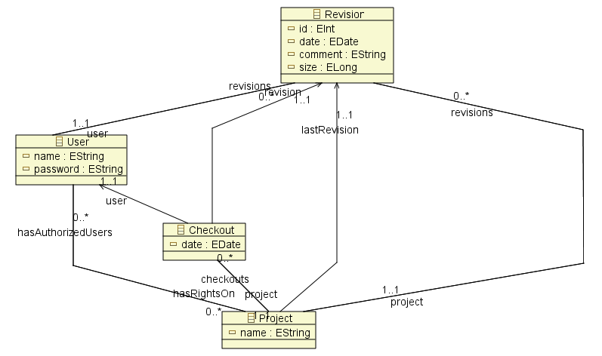

Identified restrictions and inefficiencies
- Every string is stored as a separate record, this could make performance a bit slower.
- Schema evolution is totally unsupported, things could go wrong on every level. For example using the ordinal values of enumerations makes it impossible to insert extra items (adding could still work).
- Not all primitive types are yet defined, they will be added along the way
- The “transient” property of EMF references/attributes (when true meaning not to store this value) will at first not be taken into account
- Lists will be handled as if order is important, also when not necessary
- The maximum number of objects in one database are 2⁶³-1
- The maximum number of revisions for one project are 2³¹-1
- The maximum number of projects in one database are 2³¹-1
- The maximum amount of blob's in one database is 2³¹-1
- The maximum number of known classes in one database is 2¹⁵-1
- Null-values for attributes and references take up as much space as non-null values
- When storing multiple projects in one database, based on a different class-structure, class-names cannot conflict with each other.

Indexing
To efficiently query a database indexes are necessary. Some databases like BerkeleyDB provide one or more secondary databases for this purpose, but this could also be implemented in normal tables.

To be written.

API
To be written.

Use cases

Use case 1
See illustration on the next page, which is an object state (like) diagram

Revision 1:
There are two objects with some properties, Object A is referencing Object B.

Revision 2:
Someone changes attribute “z” of Object B from 3 to 4. Now there are 3 objects in the database. Note that re-construction of both model-revisions are still possible, but without storing the unchanged object double.

Revision 3:
Now a user disconnects the reference A had to B (but B itself is not deleted). This time there will only be a new revision for Object A. This is revision 3. Still it is possible to reconstruct.
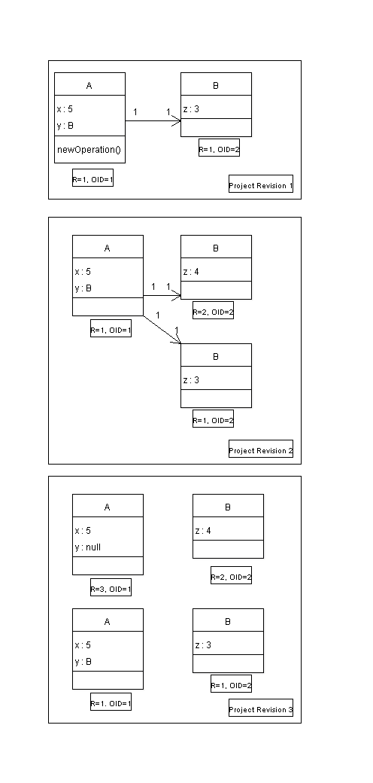
Use Case 2

ChangeSet {
additions: List<Addition>
modifications: List<Modification>
removals: List<Removal>
}

Addition {
className: String
oid: Long
attributeValues: List<AttributeValuePair>
}

Modification {
className: String
oid: Long
attributeValues: List<AttributeValuePair>
}

Removal {
className: String
oid: Long
}

AttributeValuePair {
name: String
type: String
value: Object
}

ChangeSetResult {
addedOids: List<Long>
}

Opmerkingen:
- Bij modications en additions hoeven niet alle attributes meegegeven te worden
- Bij additions worden alle niet meegegeven attributes op default values ingesteld
- Bij modification blijven alle niet meegegeven attributes onveranderd
- Bij additions mag een eigen oid verzonnen worden om deze refeerbaar te maken, dit id moet negatief en uniek zijn om conflicten met de database te vermijden
- Vanuit Modifications en Additions mag oid verwijzen naar een daadwerkelijk oid (in de database), of een tijdelijk oid zoals vermeld
- De 'value' van een AttributeValuePair moet van het type zijn gedefinieerd in 'type'
- ChangeSetResult bevat in dezelfde volgorde als aangeleverd in de changeset de gegeneerde ID's van de
respectievelijke objecten, zodat de client dit kan verwerken voor latere communicatie

